

**System Design Specification**  **Document – Service Desk**

# Project: Rwanda Safe City Project

(Phase 1)

Version 0.3

08/07/2021

Page **0** of **30**

## CONTENTS

1. ***Document Management ............................................................................................ 3***

 **Contributors ................................................................................................................... 3**

 **Version Control .............................................................................................................. 3**

 **Review and Approval ...................................................................................................... 4**

1. ***Introduction .............................................................................................................. 5***

 **Intended Audience ......................................................................................................... 5**

2.1.1 References ...................................................................................................... 5

 **Purpose of the SDD ......................................................................................................... 5**

 **Document Conventions and Abbreviations ...................................................................... 5**

1. ***Business Requirements .............................................................................................. 6***

 **Requirements Overview ................................................................................................. 6**

 **Overview of Business Process Flow ................................................................................. 6**

 **User Classes and Characteristics ...................................................................................... 6**

 **Data Sources .................................................................................................................. 8**

 **Functional Requirements ................................................................................................ 8**

3.5.1 Incident Management..................................................................................... 8

3.5.2 Service Requests ........................................................................................... 12

3.5.3 Change Management .................................................................................... 13

3.5.4 Knowledge Management .............................................................................. 14

3.5.5 Self-Service Portal ......................................................................................... 14

3.5.6 Reporting....................................................................................................... 15

 **Automation Requirements ............................................................................................ 16**

 **Non-Functional Requirements ...................................................................................... 17**

3.7.1 System Performance ..................................................................................... 17

3.7.2 System Capacity ............................................................................................ 18

3.7.3 System Scalability and Flexibility .................................................................. 18

3.7.4 System Usability ............................................................................................ 19

3.7.5 System Availability ........................................................................................ 20

3.7.6 System Operability ........................................................................................ 21

3.7.7 System Accessibility and Security ................................................................. 22

1. ***Detailed Design ....................................................................................................... 25***

 **Hardware Specifications ............................................................................................... 25**

4.1.1 Production Environment ............................................................................... 25

4.1.2 Staging Environment ..................................................................................... 25

4.1.3 Storage Sizing ................................................................................................ 26

4.1.4 Network Architecture ................................................................................... 26

 **Software Design ........................................................................................................... 28**

 **Database Design ........................................................................................................... 28**  **System Architecture Detailed Design ............................................................................. 28**

4.4.1 Software Architecture ................................................................................... 28

1. ***Assumptions/Risks .................................................................................................. 29***

 **Assumptions ................................................................................................................. 29**

 **Risks ............................................................................................................................. 29**

|  |  |
| --- | --- |
| 1 | DOCUMENT MANAGEMENT |

|  |
| --- |
| CONTRIBUTORS |

|  |  |  |
| --- | --- | --- |
| **Role** | **Unit** | **Name** |
| Senior Business Analyst | ICT | Younes Najif |
|  |  |  |
|  |  |  |
|  |  |  |
|  |  |  |
|  |  |  |

|  |
| --- |
| VERSION CONTROL |

|  |  |  |  |  |
| --- | --- | --- | --- | --- |
| **Date** | **Version** | **Author** | **Section** | **Amendment** |
| 11/26/2020 | 0.1 | Younes Najif | ICT | First Draft |
| 12/21/2020 | 0.2 | Younes Najif | ICT | First Draft |
| 03/01/2021 | 0.3 | Younes Najif | ICT | Updated according to provided user comments |
|  |  |  |  |  |

|  |
| --- |
| REVIEW AND APPROVAL |

|  |  |  |  |  |
| --- | --- | --- | --- | --- |
|  | **Designation** | **Name** | **Signature** | **Date** |
| **Prepared By** | **Senior Business Analyst** | **Younes Najif** |  | **26/11/2020** |
| **Reviewed By** |  |  |  |  |
| **Approved By** |  |  |  |  |

|  |  |
| --- | --- |
| 2 | INTRODUCTION |

|  |
| --- |
| INTENDED AUDIENCE |

The system design document is intended for Systems and Business Analysts Team of Rwanda National Police, IT Department, and Project Management Team.

The content of this document describes technical details of the Service Desk. Therefore, all relevant departments are required to review and handle this document.

### 2.1.1 REFERENCES

|  |  |
| --- | --- |
| Document Title | Date/Version |
| Technical Proposal Document | V1 |
|  |  |
|  |  |

|  |
| --- |
| PURPOSE OF THE SDD |

The main purpose of the SDD document is to list and describe the complete system requirements for implementing the Service Desk platform and software application for Rwanda National Police. That includes the functional, non-functional, system integration, and hardware requirements.

|  |
| --- |
| DOCUMENT CONVENTIONS AND ABBREVIATIONS |

*The document assumes these typographical Abbreviation:*

|  |  |
| --- | --- |
| Abbreviation | Description |
| SD | Service Desk |
| RNP | Rwanda National Police |
| SDD | Systems Design Document |
| API | Application Programming Interface |
| GIS | Geographical Information System |
| SSO | Single-Sign On |
| UI | User Interface |

|  |  |
| --- | --- |
| 3 | BUSINESS REQUIREMENTS |

This document section describes on a high-level the business requirements for the Service Desk system.

|  |
| --- |
| REQUIREMENTS OVERVIEW |

The service desk system aims to digitize and streamline daily processes of reporting the IT systems issues, handling support tickets, keeping track of the progress, and resolving them.

Service desk tool is essential to maintain smooth and streamlined operations, the service desk and service management system is an integrated modular solution that is required to align IT and business strategy through the support and advancement of business-critical functions.

For this purpose, it is required to implement a Service Desk platform that caters the below:

* Incident Management (For IT Systems)
* Service Requests
* Change Management
* Service-Level Management
* Knowledge Management - Reporting Module

|  |
| --- |
| OVERVIEW OF BUSINESS PROCESS FLOW |

The current/to-be business processes will be designed and drafted jointly with all project stakeholders and end-users.

|  |
| --- |
| USER CLASSES AND CHARACTERISTICS |

|  |  |  |
| --- | --- | --- |
| User Class | User Role | Description |
| Service Desk  Analyst/Manage r | Administrative /  Non-Administrative | The service desk analyst role has administrative and nonadministrative privileges that includes receiving and logging reported support tickets and requests, tickets assignments, tracking issues, first-level support, resolving tickets and requests, updates and reporting. |
| Support Engineer | Administrative /  Non-Administrative | The support engineer role has administrative and nonadministrative privileges that includes receiving assigned support tickets and requests, second-level support, resolving tickets and requests, updates and reporting. |
| End-User | Non-Administrative | The end-user will have access to the service desk with nonadministrative privilege, where he/she will be reporting support tickets and raising requests, receive progress notifications of related support tickets and requests. |
| Administrator | Administrative | The administrator will have access to the system with super user privileges to manage and configure all system modules and settings, troubleshoot issues, and maintain the overall system technical aspects. |

The below teams are required to be configured in the system for tickets assignments and related transactions:

|  |  |
| --- | --- |
| Team name | Provided by RNP |
| On-Site Support | * Team Email: * Team manager: * Users in the team: |
| Network Support | * Team Email: * Team manager: * Users in the team: |
| Service Desk | * Team Email: * Team manager: * Users in the team: |
| Server Support | * Team Email: * Team manager: * Users in the team: |
| Application Support | * Team Email: * Team manager: * Users in the team: |

|  |
| --- |
| DATA SOURCES |

We assume that there might be some data sources require integration to send or receive tickets from however at this point, these sources are not clear and will be added on after detailed analysis and requirement received from client.

|  |
| --- |
| FUNCTIONAL REQUIREMENTS |

### 3.5.1 INCIDENT MANAGEMENT

This module will Capture, identify and respond to issues and service requests across the organization (Rwanda National Police).

Enable service management teams to automate incident processes and communications to quickly understand and restore service operations.

Analyze incidents from top to bottom to understand performance.

The below are the main functional requirements within incident management module:

**1) Incident Detection and Recording**

Users can submit an incident by:

* Using the Self-Service Portal: A user creates an incident from the Self Service portal and the system notifies the Service Desk Manager who assigns the incident to a Service Desk analyst.
* Contacting the Service Desk by phone: A user calls the Service Desk. A Service Desk Analyst then creates an incident.

* The application automatically assigns a unique reference number and date time stamp (CreatedDateTime) to each incident.
* End users and Service Desk Analysts can search the Knowledge Base for solutions during incident recording. If a resolution exists in the Knowledge Base, the Service Desk Analyst resolves the incident without further action.

* 1. **Incident Classification and Support**

Classifying and initially supporting an incident is accomplished by the following:

* In the Incident workspace, classifies incidents by service and category (provided in the last section of this document). When a service is selected from the drop-down list, the category menu is populated and filtered with options from the service that you selected.
* Categorizing incidents not only identify services that failed, but also configuration items that encountered failures. This allows the application to identify trends in failures of similar services or categories. Categorization is also useful for reporting purposes.
* Service level agreements will be linked to incidents. (provided in the Service-

Level Management section of this document)

* + Impact: The impact is the extent to which the loss of service will impact the business organization. For example, if a single application is down, it will have less business impact than a server being down.

* + Urgency: The affected user's tolerance for resolution delay. Urgency is usually time related. For example, the loss of network connectivity at the busy working daytime might be assigned a greater urgency than at another time.

* + Priority: The order in which it needs to be resolved, based on impact and urgency.

* 1. **Incident Resolution and Recovery**
* When a Service Desk Analyst fixes an incident, they set the status to resolved. (this is the target)
* The application tracks escalations, as configured by service level agreements of active incidents. An incident is considered breached if a Service Desk Analyst does not respond to and resolve it within a certain amount of time.
* During the initial classification of an incident, you can match the incident to another incident, a problem, or a Knowledge Base article by searching on the keywords in the Summary field of the incident. If the application finds a resolution or workaround, you can bypass the investigation and diagnosis process and resolve the incident.
* Incidents can be resolved during the initial contact with the Service Desk, thus ensuring a quicker restoration of normal service for the end user.
* The objective of incident management during an incident is to restore normal service as quickly as possible. The objective is not to make an application perfect.

* 1. **Incident Closure**
* The application automatically closes an incident that is in the resolved status after proposed period of 7 days.
* The system also closes incidents after 28 days if there is no further communication from the user (If status waiting for end-user response). The system sends a reminder for the end-user after 14 days if the status is waiting for end-user response.
* The user or a Service Desk Analyst can reopen incidents that are in the resolved state if the resolution is not satisfactory.
* After the incident is set to closed. The system sends a link to a survey to the user, giving them an opportunity to rate the effectiveness of the Service Desk in resolving the incident.
* When an incident is closed, it remains in the application and can be viewed for reporting and analytic purposes. Service Desk Managers can view and generate dashboards and reports to determine how the Service Desk performed against service level agreements.

* 1. **Incident Fields**

|  |  |
| --- | --- |
| Field | Description |
| Customer  (End-User) (End-User) | The name of the person who has an issue. The application automatically adds the email address, phone number, and location below the Customer (End-User) name. PF need to provide a list of users, Click here to know more |
| Summary | A summary of the incident |
| Description | The description of the incident with relevant details. |
| Service | The affected service that is impacted (this is provided in the last section of this document, Click here to know more) |
| Category | The category (this is provided in the last section of this document, Click here to know more ) |
| Urgency | Specifies the time appropriateness required. The default value is MEDIUM (this is provided in the last section of this document, Click here to know more ) |
| Impact | Specifies the impact to the organization, group, or individual. The default value is MEDIUM. Impact and urgency together define the priority value: (this is provided in the last section of this document, Click here to know more) |
| Status | The status of the incident. (this is provided in the last section of this document, Click here to know more) |
| Team | The team to work on the incident (this is provided in the last section of this document, Click here to know more) |
| Owner | The login ID of the Service Desk Analyst who is assigned to work on this incident |
| Source | Describes how the incident was submitted (this is provided in the last section of this document, Click here to know more) |
| Resolution | Contains the resolution information |
| Cause Code | Contains the root cause of the incident. Choose the desired option from the drop-down list (this is provided in the last section of this document, Click here to know more) |
| Actual Service | The application automatically fills in the value for this field, although you can change it if you need to |
| Actual  Category | The application automatically fills in the value for this field, although you can change it if you need to. |
| Attachment | Contains attachments |
| Asset | Contains links to other business object (such as a configuration item) to this record |
| Audit Info | Lists the date and time when the incident was created and the date and time when it was last modified |
| Journal | Contains comments or notes about this incident |

* 1. **Incident Status**

Below is the status that would be available and below some information how later these statuses will be used:

|  |  |  |
| --- | --- | --- |
| From State | To State | When |
| Logged | Active | The incident is submitted from the Self Service portal in a logged state and is set to active when the Service Desk Analyst opens and saves the incident. |
| Active | Waiting for  Customer  (End-User) | Information is needed from the Customer (EndUser), based on the service desk analysis |
| Waiting for 3rd Party | A vendor is assigned to the incident |
| Waiting for Resolution | Incident identified as a problem |
| Resolved | The incident is resolved; typically a first-call resolution |
| Waiting for  Customer  (End-User) | Waiting for  3rd Party | The vendor is assigned the incident based on additional information from the Customer (EndUser) |
| Waiting for Resolution | Additional information from the Customer (EndUser) identifies the incident as a problem |
| Resolved | Additional information from the Customer (EndUser) resolved the incident |
| Waiting for 3rd Party | Waiting for  Customer  (End-User) | Information is needed from the Customer (EndUser), based on the analysis of the vendor |
| Waiting for Resolution | The vendor identifies the incident as a problem. |
| Resolved | The vendor resolves the incident. |
| Waiting for Resolution | Resolved | The problem is resolved. |

### 3.5.2 SERVICE REQUESTS

The Service Requests module will be required to capture, identify and respond service requests across the organization.

Enable service management teams to automate request fulfilment processes and communications to quickly understand the user and environment requirements.

Analyze requests from top to bottom to handle them.

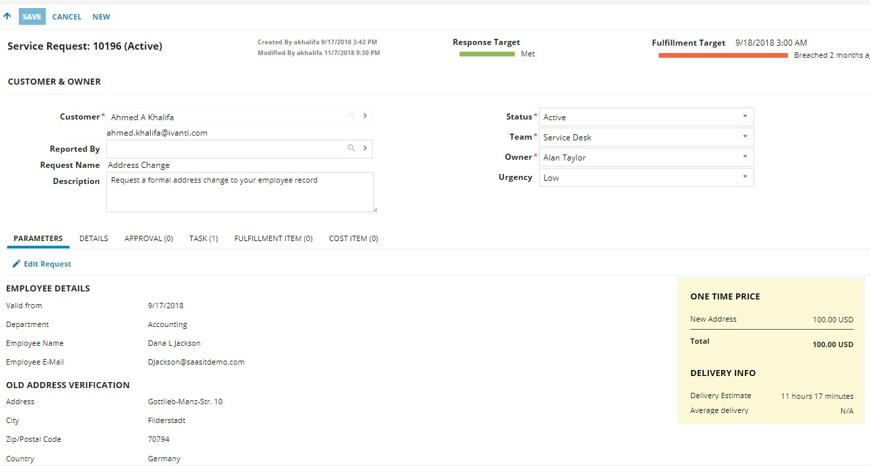

### 3.5.3 CHANGE MANAGEMENT

The change management module will be required to manage, track and optimize changes to IT hardware, software, system components, documentation, and processes by minimizing the impact of change and ensuring that the business goals and IT services are in constant alignment.

Support for industry best practices and regulatory by linking of related Incident and Changes.

Set schedule of change and approval process.

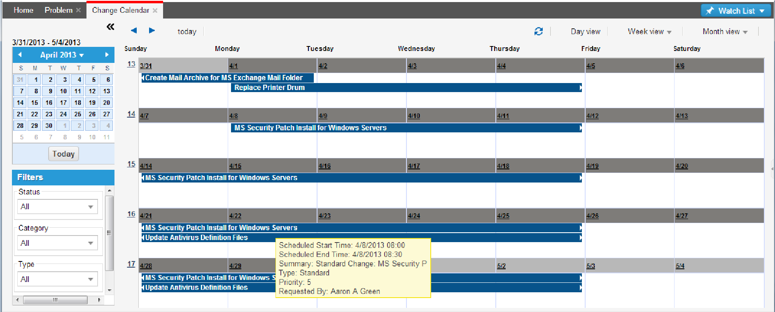

### 3.5.4 KNOWLEDGE MANAGEMENT

The Knowledge Management module and database is required on the user portal as well as the technician’s view. Knowledge Base articles can be assigned to the right target group.

A Knowledge Management process for publishing and reviewing is in place that enables Knowledge Managers to enable Knowledge Articles for internal or external access.

The knowledge management module will use Object Matching that enables the automatic searching of Knowledge articles when the Summary of an Incident is captured.

### 3.5.5 SELF-SERVICE PORTAL

The Self-Service Portal will be required to provide a web-based self-service tool, opening up the service desk for 24x7 customer (end-user) access.

Internal end-users can submit and track requests themselves, and users will always know where to turn to get the IT service they need, anytime, anywhere.

The self-service portal will be used to expose knowledge articles to end-users,

Increase service levels while lowering costs, extend hours’ service is available, Increase satisfaction, lower incoming call volumes, reduce per-incident costs, and free service desk staff to focus on resolution.

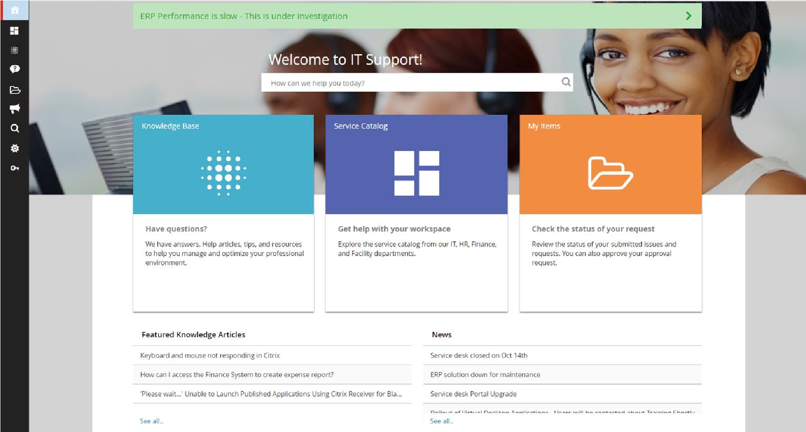

### 3.5.6 REPORTING

The management reporting module will be required for providing data insights of the below:

* Incidents Reports
* Service Requests Reports
* Change Request Reports
* Tickets Assignments and Assignees
* SLA Reports
* Configuration Items Reports

The reporting engine will be used to create service views that presents users of all levels, roles-based perspectives into varying areas of the business.

The Dashboard views will consist of user defined configurations of either system supplied or configured Dashboard parts. A wide variety of dashboard reports are included Out of the Box; however, end-users can easily add or extend the included dashboard to meet their exact needs through front end wizard-based actions.

Dashboard reports have provided customers with the ability to engage with data at a raw level to have comprehensive visibility of the entire infrastructure and service. From dashboards, filters can be applied to create historical reports.

|  |
| --- |
| AUTOMATION REQUIREMENTS |

The development and implementation process of the Service Desk System will consider automating all what can be achieved by software code automatically without the need for end-user’s manual intervention. The general system automation requirements are specified as below:

* **Processes and Workflows.**

Automation of all business processes, procedures and workflows is required and will be considered while modelling and implementing them in the system. Inputs and outputs of these processes should auto trigger the interconnected processes and sub-processes end-to-end.

* **Repetitive Tasks.**

Repetitive tasks will be identified and eliminated through system automation to focus on productive business aspects.

* **Scheduling.**

Tasks scheduling of all jobs is required to ensure the specified work gets done on time as planned.

* **Data Entry.**

Manual data entry fields for details and information will be minimized and eliminated where applicable. The below automation techniques will be used while designing and implementing the system:

1. Auto populate data in their respective fields.
2. Auto suggest entries to be selected while typing.
3. Auto generate selection lists and checklists.
4. Drop-down menus instead of plain text fields.
5. Choose from ready-made templates.
6. Define restriction and validation rules to ensure automation of data verification and accuracy.
7. Auto hide/display required fields

* **Data Collection, Sync and Update.**

The SERVICE DESK collect data from the defined data sources, to trigger processes and business rules and view real-time data on reports and dashboards.

* **Communication.**

System alerts and notifications will be auto triggered upon initiated, opened, completed, and closed actions or tickets, systematic or through end-users, then automatically sent to all relevant defined stakeholders in the business process.

|  |
| --- |
| NON-FUNCTIONAL REQUIREMENTS |

### 3.7.1 SYSTEM PERFORMANCE

The Service Desk System will meet the below listed performance requirements as part of the non-functional requirements:

|  |  |
| --- | --- |
| Non-Functional Category | System Performance |
| Sub-Category | Response Time and Latency |
| Description | The UIS system services will have an acceptable response time that will meet the below conditions:     * The system performed user's actions will be reacting instantaneously. * The system responses and dialogues will keep the users focused and uninterrupted. * The system response time will be symmetric and not variable for the same function. * Providing suitable network environment, the system will operate with the defined network latency. * The system response time and latency will be measurable, constantly monitored and reported. |
| Applicable System/Service | Service Desk System |
|  |  |
| Sub-Category | Workload and Throughput |
| Description | To achieve acceptable response times and overall system performance, the system workload will meet the below conditions:    - The system workload will support 3000 users and a peak of  5000 users without upgrading the initial environment |
|  | (software/hardware) setup.   * The system will support the business defined expected number of read/write transactions and the defined peak transactions without upgrading the initial environment (software/hardware) setup. * The system will be capable of processing all business defined volumes of requests, tasks and activities, hourly & daily, monthly & annually, average and defined peak. - The system workload will support both; regular and burst received traffic. * The system workload and throughput will be measured, constantly monitored and reported. |
| Applicable System/Service | Service Desk System |
|  |  |
| Sub-Category | Concurrency |
| Description | The Service Desk system will support concurrent users' access sessions and users'/systems' transactions (Read/Write). |
| Applicable System/Service | Service Desk System |

### 3.7.2 SYSTEM CAPACITY

The Service Desk System will meet the below listed capacity requirements as part of the non-functional requirements:

|  |  |
| --- | --- |
| Non-Functional Category | System Capacity |
| Sub-Category | N/A |
| Description | * Providing the suitable environment, the system will be capable of storing business data and relevant information at defined initial volumes and peak volumes.      * The system capacity will meet the defined data retention and archival business rules. |
| Applicable System/Service | Service Desk System |

### 3.7.3 SYSTEM SCALABILITY AND FLEXIBILITY

The Service Desk System will meet the below listed scalability requirements as part of the non-functional requirements:

|  |  |
| --- | --- |
| Non-Functional Category | System Scalability and Flexibility |
| Sub-Category | N/A |
| Description | The system will be capable to accommodate new business services, new business processes and new integration as the business requires.    It will be easy to introduce changes and modifications to the system software as the business requires for adopting the new business services, business processes and integrations. |
| Applicable System/Service | Service Desk System |

### 3.7.4 SYSTEM USABILITY

The Service Desk System will meet the below listed usability requirements as part of the non-functional requirements:

|  |  |
| --- | --- |
| Non-Functional Category | System Usability |
| Sub-Category | User Interface |
| Description | The system user interface will be designed and customized to meet the below conditions:     * The interface design will take in consideration all user interface elements including: input controls, navigation components, informational components and containers. * The interface design will be minimal, clean and comprehensive. * The interface branding will adhere to Rwanda   National Police RNP standards and requirements. |
| Applicable System/Service | Service Desk System |
|  |  |
| Sub-Category | User Experience |
| Description | The system will support the following from the perspective of its primary users:     * The system will be easy to access. * The system will be easy to learn. * The system will be user-friendly (easy to use) with no or less errors. * The system will be informative in case of errors. - The system will be efficient at helping users achieve their tasks. |
| Applicable System/Service | Service Desk System |

### 3.7.5 SYSTEM AVAILABILITY

The Service Desk System will meet the below listed availability requirements as part of the non-functional requirements:

|  |  |
| --- | --- |
| Non-Functional Category | System Availability |
| Sub-Category | Base Availability |
| Description | The system will operate and comply with the defined SLAs by Rwanda National Police RNP outside scheduled maintenance periods.    Availability outside scheduled maintenance periods will be measured using a declared and agreed method. |
| Applicable System/Service | Service Desk System |
|  |  |
| Sub-Category | Software Architecture |
| Description | The software architecture will be designed and implemented with microservices, where the application is required to be built as a suite of small services, each running in its own process and are independently deployable.    The system will support queuing as a technique to be able to continue to receive incoming requests and messages even if incapable of completing processing at that time. In addition, the system will provide controls and functionality such that all received requests are processed and applicable processes and responses are made. |
| Applicable System/Service | Service Desk System |
|  |  |
| Sub-Category | Hosting Environment |
| Description | Providing the suitable hosting environment, the system will support the high-availability setup including:     * Load Balancing. * Redundancy and Failover. * Service and Data Recovery. |
| Applicable System/Service | Service Desk System |

### 3.7.6 SYSTEM OPERABILITY

The Service Desk System will meet the below listed interoperability requirements as part of the non-functional requirements:

|  |  |
| --- | --- |
| Non-Functional Category | System Interoperability |
| Sub-Category | Presentation |
| Description | The system will be capable of integrating with other systems at the presentation layer seamlessly to share the look-and-feel, as well as the underlaying functionality where the business requires. |
| Applicable System/Service | Service Desk System |
|  |  |
| Sub-Category | Information |
| Description | The system will be able to integrate with other systems at the data layer to share information seamlessly where the business requires. |
| Applicable System/Service | Service Desk System |
|  |  |
| Sub-Category | Application |
| Description | The system will be able to integrate with other systems where required, to share business processes, and modules to avoid duplication of business applications. |
| Applicable System/Service | Service Desk System |
|  |  |
| Sub-Category | Hosting Environment |
| Description | The system will support operating in a shared and dedicated resource hosting infrastructure. |
| Applicable System/Service | Service Desk System |

### 3.7.7 SYSTEM ACCESSIBILITY AND SECURITY

The Service Desk System will meet the below listed accessibility and security requirements as part of the non-functional requirements:

|  |  |
| --- | --- |
| Non-Functional Category | System Accessibility and Security |
| Sub-Category | Confidentiality |
| Description | The system will protect against disclosure of its data to unauthorized entities and individuals.    The confidentiality of data will be enforced at all levels (at rest, processing, and in-transit).    Th system will support data Encryption and  Steganography through secure protocols including:  HTTPs and SSL. |

|  |  |
| --- | --- |
| Applicable System/Service | Service Desk System |
|  |  |
| Sub-Category | Integrity |
| Description | The system will ensure integrity, accuracy and reliability of exchanged data and information.    The system will support implementation of security controls including: Hashing and Digital Signature. |
| Applicable System/Service | Service Desk System |
|  |  |
| Sub-Category | Availability |
| Description | The system will support implementation of security controls to protect against unwanted destruction or disruption of service, including: Anti-DDoS hardware and software. |
| Applicable System/Service | Service Desk System |
|  |  |
| Sub-Category | Authentication |
| Description | The system will ensure legitimacy and validity of identities willing to access it.    The system will support implementation of authentication mechanisms and methods, including: Active Directory, Multi-Factor Authentication (Token), Single Sign-On (SSO). |
| Applicable System/Service | Service Desk System |
|  |  |
| Sub-Category | Authorization |
| Description | Role Based Access Control (RBAC) will be used to provide the system users with access roles (System user, Supervisor, Admin) to each system module, as well as define the access rules for each user (Read/Write, Read-Only). |
| Applicable System/Service | Service Desk System |
|  |  |
| Sub-Category | Accountability |
| Description | The system will support implementation of logging and auditing to capture, monitor and audit HowWhat-When users are accessing and making changes in the system. |
| Applicable System/Service | Service Desk System |
|  |  |
| Sub-Category | Assurance |
| Description | The system will be built following the defined Rwanda National Police RNP’s security and privacy standards and policies. |
| Applicable System/Service | Service Desk System |

|  |  |
| --- | --- |
| 4 | DETAILED DESIGN |

This document section provides detailed design and specifications of the systems hardware and software.

|  |
| --- |
| HARDWARE SPECIFICATIONS |

### 4.1.1 PRODUCTION ENVIRONMENT

|  |  |  |  |  |  |  |  |  |
| --- | --- | --- | --- | --- | --- | --- | --- | --- |
| **Application** | **Application2** | **Type** | **Phase** | **Target** | **Disk C** | **Disk D** | **CPU** | **Memory** |

|  |  |  |  |  |  |  |  |  |
| --- | --- | --- | --- | --- | --- | --- | --- | --- |
| Accident Reporting & Service Desk | Web - 1 | VM | 1 | Production | 200 | 200 | 4 | 8 |
| Accident Reporting & Service Desk | Web - 2 | VM | 1 | Production | 200 | 200 | 4 | 8 |
| Accident Reporting & Service Desk | App - 1 | VM | 1 | Production | 200 | 200 | 4 | 8 |
| Accident Reporting & Service Desk | App - 2 | VM | 1 | Production | 200 | 200 | 4 | 8 |

|  |  |  |  |  |  |  |  |  |
| --- | --- | --- | --- | --- | --- | --- | --- | --- |
| Shared MS SQL Server Reporting Server | DB 1 - MS SQL | VM | 1 | Production | 300 | 200 | 4 | 32 |
| Shared NoSQL Database | DB 1 - NoSQL - MongoDb | VM | 1 | Production | 200 | 200 | 4 | 16 |
| Shared NoSQL Database | DB 2 - NoSQL - MongoDb | VM | 1 | Production | 200 | 200 | 4 | 16 |
| Shared MS SQL Database | DB 2 - MS SQL | VM | 1 | Production | 300 | 200 | 4 | 32 |

### 4.1.2 STAGING ENVIRONMENT

|  |  |  |  |  |  |  |  |  |
| --- | --- | --- | --- | --- | --- | --- | --- | --- |
| **Application** | **Application2** | **Type** | **Phase** | **Target** | **Disk C** | **Disk D** | **CPU** | **Memory** |

|  |  |  |  |  |  |  |  |  |
| --- | --- | --- | --- | --- | --- | --- | --- | --- |
| Accident Reporting & Service Desk | Web - 1 | VM | 1 | Staging | 200 | 200 | 4 | 8 |
| Accident Reporting & Service Desk | App - 1 | VM | 1 | Staging | 200 | 200 | 4 | 8 |

|  |  |  |  |  |  |  |  |  |
| --- | --- | --- | --- | --- | --- | --- | --- | --- |
| Shared MS SQL Server Reporting Server | DB 1 - MS  SQL  Reporting  Server | VM | 1 | Staging | 300 | 200 | 4 | 16 |
| Shared MS SQL Database | DB 1 - SQL | VM | 1 | Staging | 300 | 200 | 4 | 16 |

### 4.1.3 STORAGE SIZING

|  |  |  |  |  |
| --- | --- | --- | --- | --- |
| **System Name** | **Incident / Day** | **Size of Data (with Images) / Incident**  **(MB)** | **Total (MB) / Day** | **Total (GB) / Month** |
| Violation System user / Service Desk System | 1,000 | 10 | 10,000 | 293 |

### 4.1.4 NETWORK ARCHITECTURE

The SERVICE DESK network architecture will follow 3-tier infrastructure pattern. This pattern divides the infrastructure into 3 separate layers: one public and 2 private layers.

The idea is that the public layer acts as a shield to the private layers. Anything in the public layers is publicly accessible but stuff in the private layers is only accessible from inside the network.

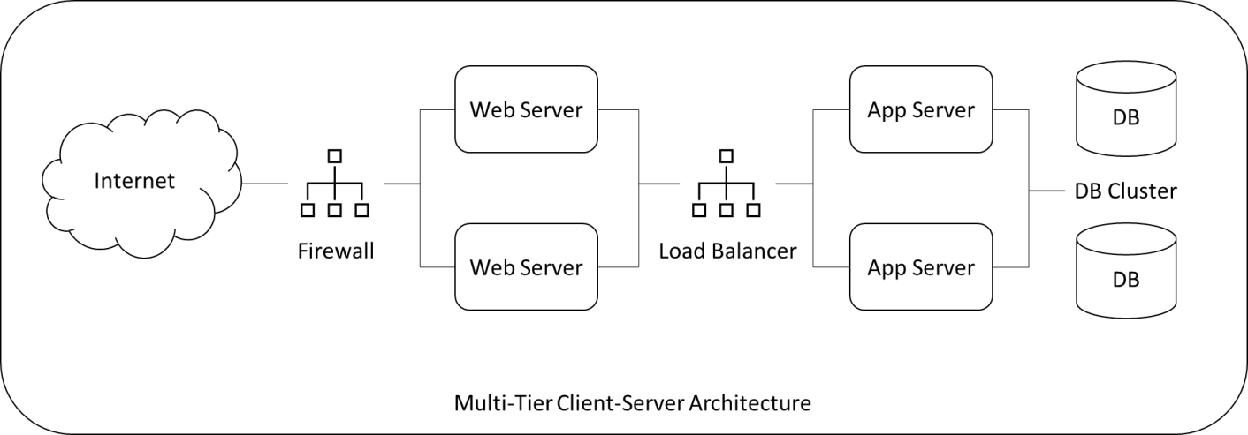

**Fron-End Layer**

It is the presentation tier is the front-end layer in the 3-tier system and consists of the user interface. This user interface is often a graphical one accessible through a web browser or web-based application and which displays content and information useful to an end user. This tier is often built on web technologies such as HTML5, JavaScript, CSS, Angular or through other popular web development frameworks, and communicates with others layers through API calls.

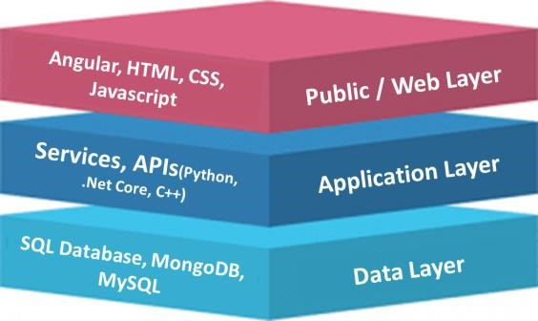**Application Layer**

This tier — also called the middle tier, logic tier, business logic or logic tier — is pulled from the presentation tier.

It controls the application’s core functionality by performing detailed processing and is usually

coded in programming languages. The application tier contains the functional business logic which Service Desk an application’s core capabilities. It’s often written in Java, .NET Core, C#, Python, C++, etc.

This is the function of the business layer which accepts the data from the application layer and passes it to the data layer.

* Business logic acts as an interface between Client layer and Data Access Layer
* All business logic – like validation of data, calculations, data insertion/modification are written under business logic layer.
* It makes communication faster and easier between the client and data layer
* Defines a proper workflow activity that is necessary to complete a task.

**Database Layer**

The third and last layer is the database layer. This is where the databases live. The only way to access these databases is by connecting to them from the application layer.

The function of this layer is to receive Service Desk the data from the business layer and performs the necessary operation into the database.

Data in this tier is kept independent of application servers or business logic, and is managed and accessed with programs, such as MongoDB, Oracle, MySQL, and Microsoft SQL Server.

|  |
| --- |
| SOFTWARE DESIGN |

The software design will follow the specified functional and non-functional requirements and services of the Service Desk System.

|  |
| --- |
| DATABASE DESIGN |

The Database design will follow the selected service desk product database design, which will follow the specified functional and non-functional requirements and services.

|  |
| --- |
| SYSTEM ARCHITECTURE DETAILED DESIGN |

The below section provides detailed system software and network architecture design and specifications for implementing and hosting Service Desk System.

### 4.4.1 SOFTWARE ARCHITECTURE

The software architecture will follow the selected service desk product software, which will follow the specified functional and non-functional requirements and services.

|  |  |  |  |
| --- | --- | --- | --- |
| 5 | | ASSUMPTIONS/RISKS | |
| ASSUMPTIONS | |

1. All listed system modules/functions are essential and must-have capabilities, which will determine the success factors of the SERVICE DESK.
2. Data cleansing process for the existing data is required prior to bulk upload activity and overall system launch (lookups)
3. The users’ roles mentioned are specific to the SERVICE DESK, not the department business roles.
4. APIs Services are required to be provided and verified prior to any required integration.
5. Further detailed design description and inputs will be documented and submitted for review and approval.

|  |
| --- |
| RISKS |

To be identified taking in consideration the below:

* End-User requirements inputs and requested changes.
* Project implementation timeline.
* Timely resolution of dependencies.